Name: ________________________________________________

1. Line AB, A(5, 1), B(2, -3), is rotated 270 degrees clockwise. What are the coordinates of B’?

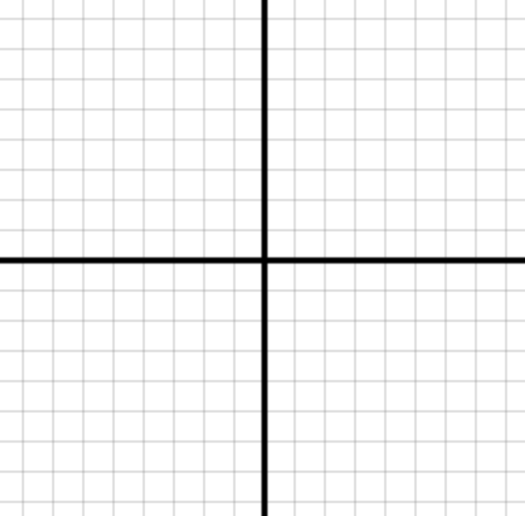

1. Triangle ABC, A(2, 5), B(5, 7), C(8, 1), is translated three units to the left and four units down. Then, that shape is rotated 90 degrees counter clockwise around the origin. What are the coordinate of B’’?



1. Point A(2, 2) goes through a rotation **and** a translation, then ends up at A’’(-4, -2). What two transformations take Point A to Point A’’?

Point A Point A’ Point A’’

(2,2) ? (?,?) ? (-4,-2)

1. Line AB, A(-2, 3) B(4, -3), is translated by the rule (x, y) → (x - 2, y + 1), then it is rotated by 180 degrees. What are the coordinates of A’’ and B’’?
2. Create your own polygon with up to six points on the coordinate grid below. Apply two different transformations to your polygon. Draw the final shape on the grid, and explain what your transformations were.



1. Experiment with reflections and dilations. In your own words, explain what each means.